**EAS 4300 Final Project**

Grayson Savage

G2434773



To find the relationship between A3=A4 and A1=A2=A5=A* a Python program was written to iterate over a range of A4/A* from 1.1 to 10.0. The maximum thrust was exceeded for values of A4/A* greater than 2.45. Because TSFC also increased with A4/A*, the minimum value of TSFC while achieving maximum thrust also occurs at this value. These ratios require solving the conservation of mass and the conservation of momentum from station 2 to station 4 in order to solve.

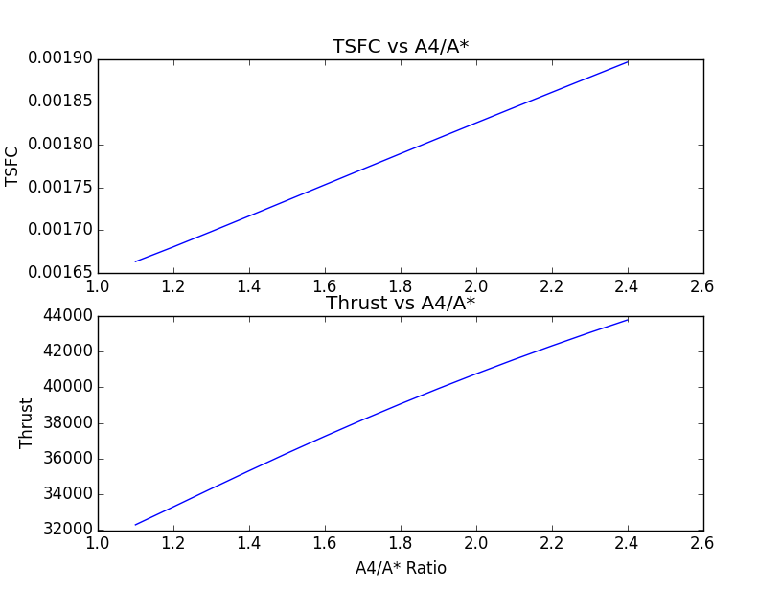

Now that the optimal area ratio for the inside of the engine has been found, this configuration was tested against a range of flight Mach numbers from 2.0 to 6.0. This range is typical of ramjets. Much lower than Mach 2.0 and the engine won’t work, and any higher than Mach 6.0, it will become a Scramjet. The assignment assumed a fixed Fb value of 0.06, so the Fb does not vary with Mach number. As a result the thrust of the engine exceeds the maximum value when operating below the design Mach number. This can be solved by adjusting the fuel to air ratio, Fb, to lower thrust into the allowable range.

The pressure ratio across the burner did vary with Mach number. This is due to differences in the mass flow rate cause by changing the incoming velocity of air. These results can be seen in the next figure.

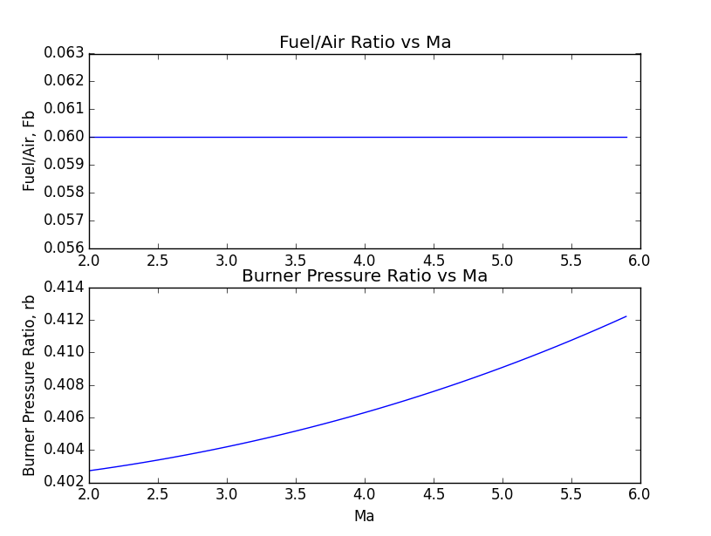

The overall efficiency of the engine was highest at the design Mach number. This is largely due to the high thermal efficiency at the design Mach number.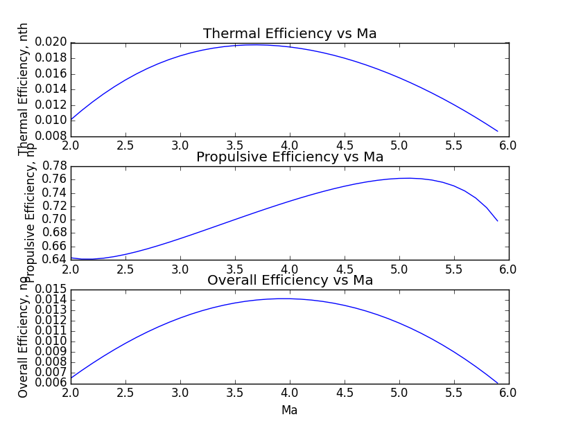

As previously mentioned, the thrust exceeded the design specifications at Mach numbers below 4.0.

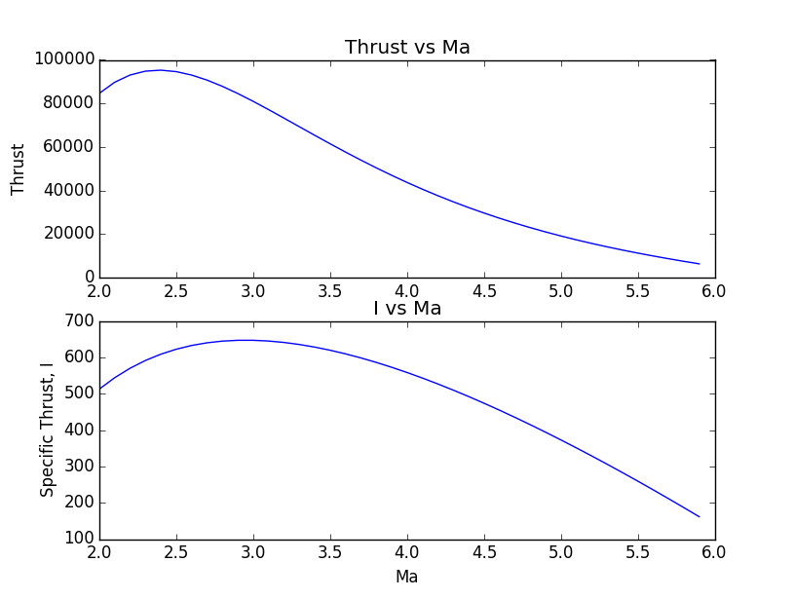

The lowest overall TSFC for the chosen A4/A* ratio occurred around Mach 3.0. This could be corrected by adjusting A/A* so that the optimal TSFC occurs at Mach 4.0. The code used to solve this problem can be found on the following pages.

